Slider Metrics

# 1.简介

# 2.相关Jira

Slider-769

AMBARI-5707

AMBARI-9437

AMBARI-9386

# 3.Ambari Metrics Service

# 4.Slider Metrics View

# 5. Slider&&AMS

使用Ambari Metrics System

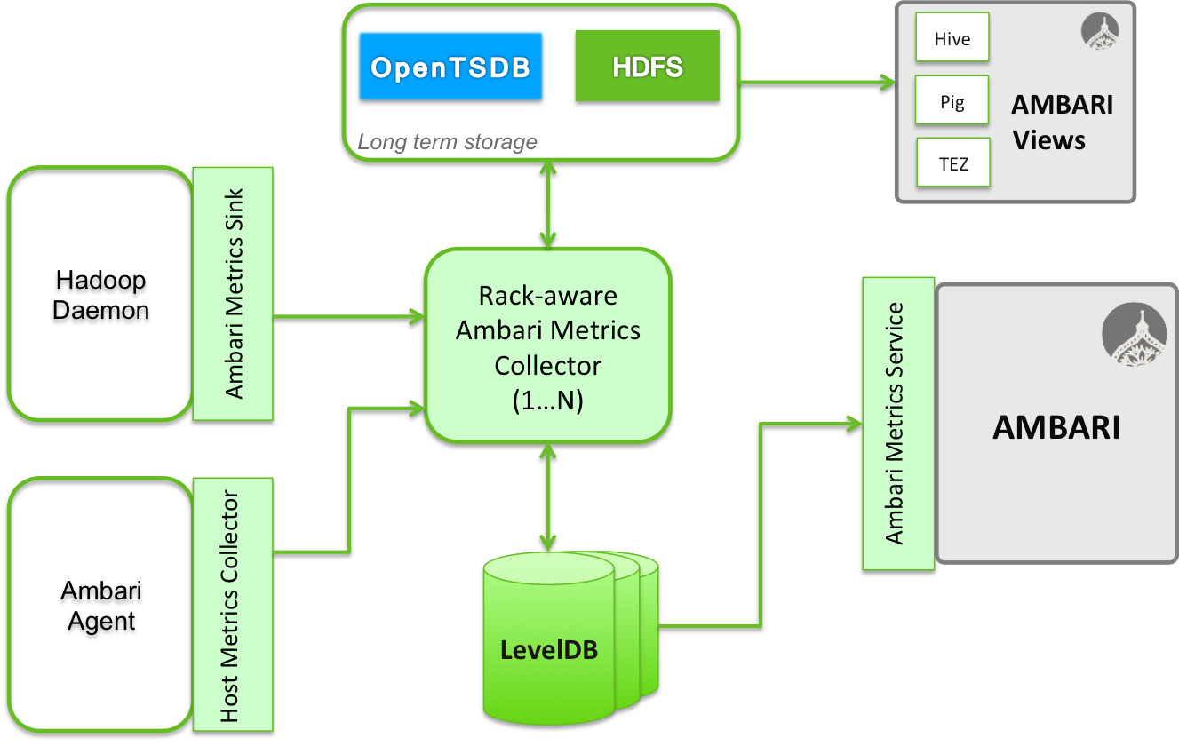

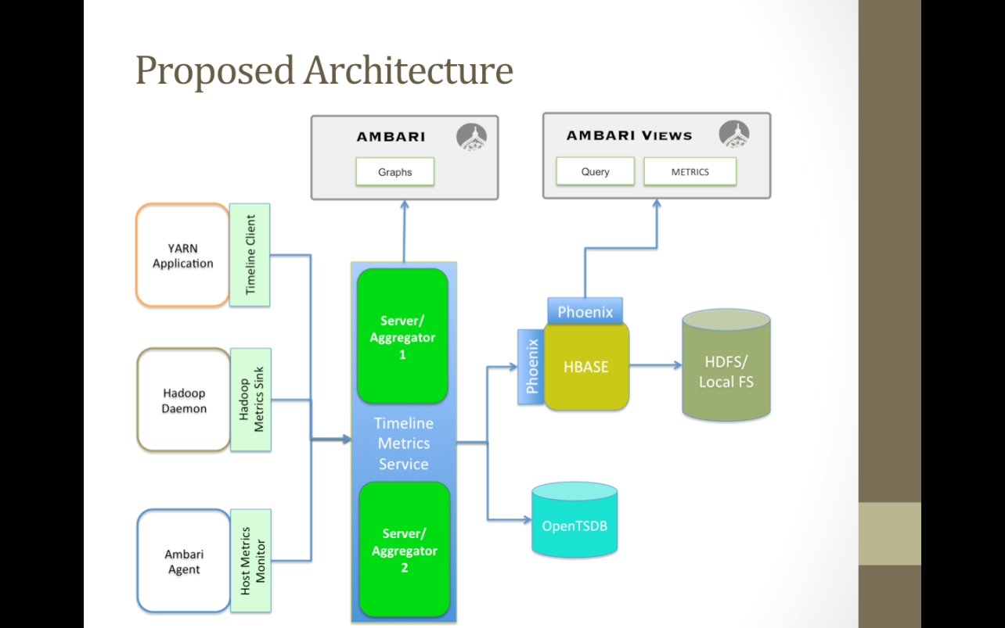

描述：